Pytest Basics and Test Discovery — Detailed Notes
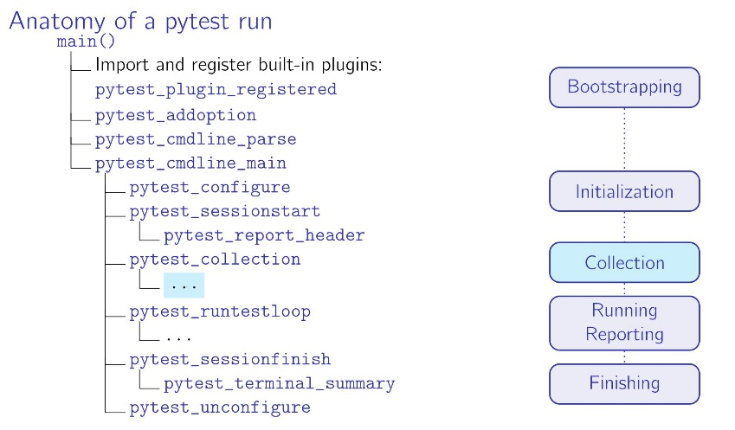
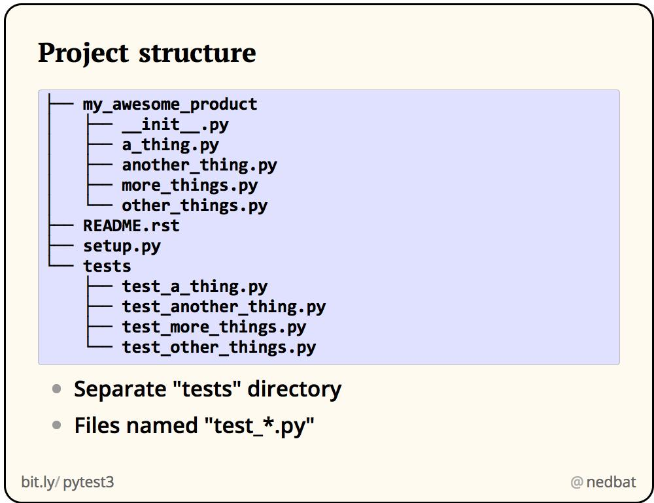
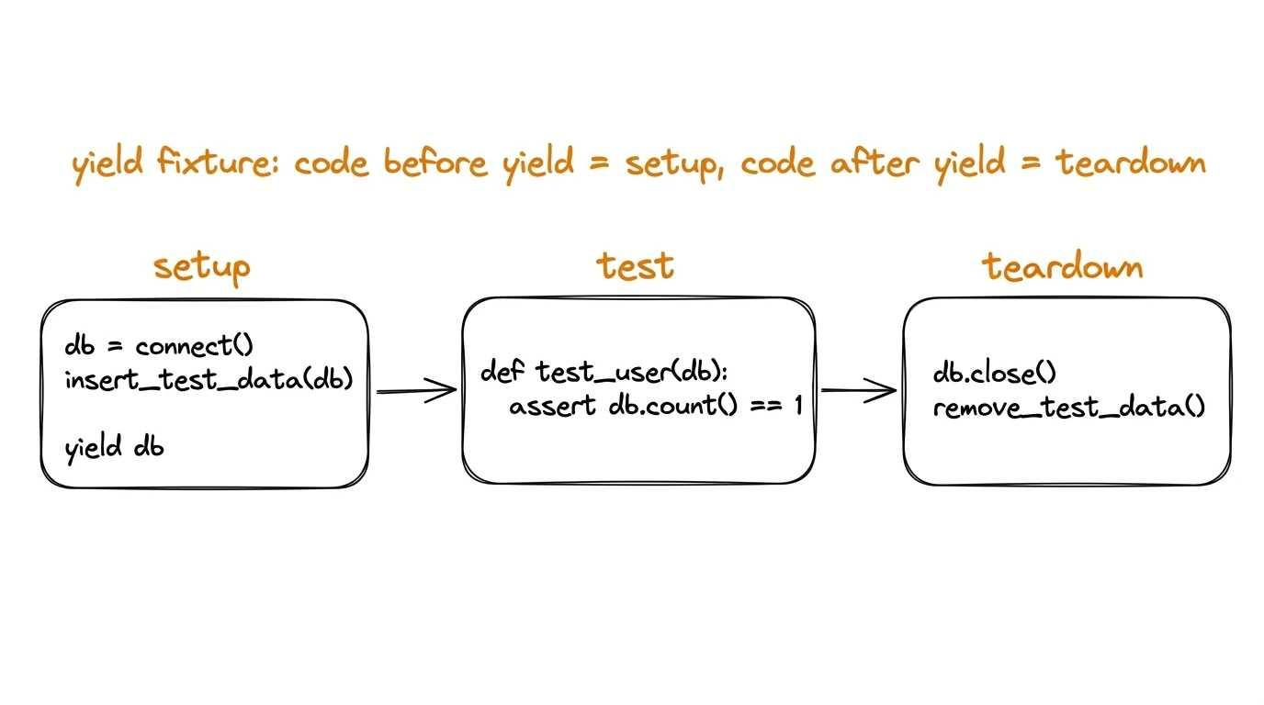
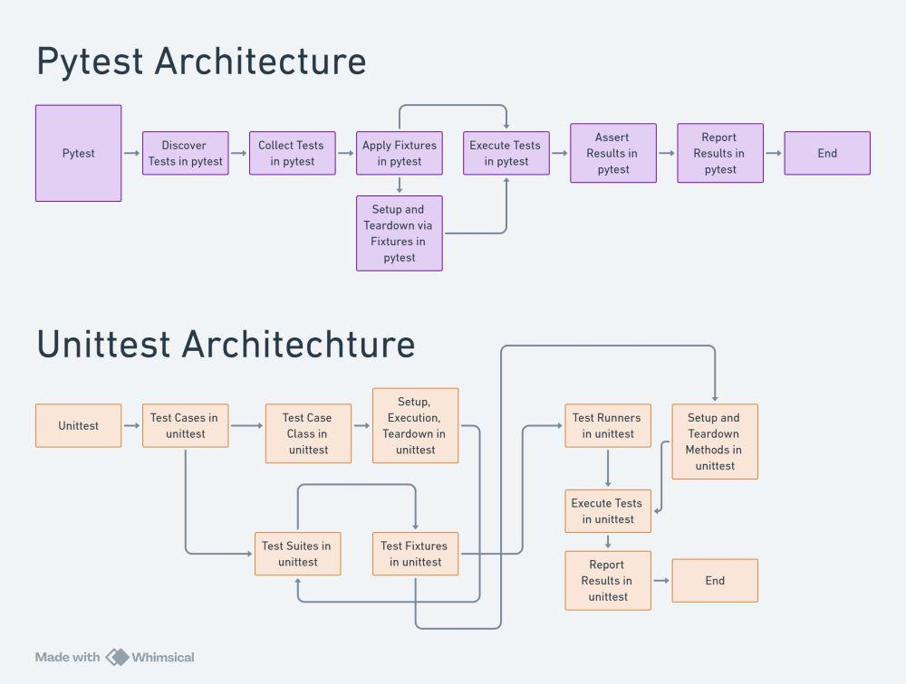
1. What is Pytest?
pytest is a popular Python testing framework used to write and execute automated tests.
It is widely used for:
- Unit testing
- Integration testing
- API automation
- Selenium automation
- Playwright automation
- Database testing
- End-to-end testing
- Data-driven testing
- Parallel test execution
The main advantages of pytest are:
- Simple syntax
- Powerful fixtures
- Automatic test discovery
- Parameterization
- Assertions using normal Python assert
- Plugins
- Markers
- Parallel execution using pytest-xdist
- HTML/Allure reporting
- Easy integration with CI/CD tools such as Jenkins and GitLab

2. Installing Pytest
Install using pip:
pip install pytest
Check the installed version:
pytest --version
Example:
pytest 8.4.2
You can also upgrade:
pip install --upgrade pytest

3. Basic Pytest Test
A simple pytest test looks like this:
def test_addition():
result = 10 + 20
assert result == 30
Run:
pytest
Expected result:
1 passed
Important point
Pytest does not require a test class.
You can directly write a test function:
def test_login():
assert True
This is one of the major differences from frameworks such as Java TestNG/JUnit where test classes are commonly used.

4. Pytest Assertion
Pytest uses Python's built-in assert.
Example:
def test_login():
username = "admin"

assert username == "admin"
Another example:
def test_status():
status_code = 200

assert status_code == 200
Common assertions
assert actual == expected
assert actual != expected
assert actual > expected
assert actual < expected
assert value is True
assert value is False
assert value is None
assert "admin" in username
Example:
def test_username():
username = "admin_user"

assert "admin" in username

5. Test Function Naming
A pytest test function normally starts with:
test_
Example:
def test_login():
pass
def test_logout():
pass
def test_create_user():
pass
But this will normally not be discovered:
def login_test():
pass
because the function does not follow the default pytest naming convention.

6. What is Test Discovery?
Test discovery means pytest automatically searches your project for files, classes, and functions that match its configured naming conventions.
For example:
project/
│
├── test_login.py
├── test_user.py
├── login.py
└── user.py
When you execute:
pytest
pytest searches the project and identifies test files such as:
test_login.py
test_user.py
Then it searches those files for test functions/classes.

7. Default Test Discovery Rules
Pytest has default rules for discovering tests.
Test files
By default, pytest looks for:
test_*.py
*_test.py
Examples:
test_login.py
test_api.py
login_test.py
user_test.py
These can be discovered.
But:
login.py
user.py
api.py
will not normally be considered test files.

8. Test Functions
Inside a discovered test file, pytest normally looks for functions beginning with:
test_
Example:
def test_login():
pass

def test_logout():
pass

def test_create_user():
pass
All three can be discovered.
But:
def login():
pass

def logout():
pass
are not test functions by default.

9. Test Classes
Pytest can also discover test classes.
Example:
class TestLogin:

def test_valid_login(self):
assert True

def test_invalid_login(self):
assert True
The class normally needs to start with:
Test
Example:
class TestLogin:
...
Important
Do not normally define an __init__() constructor in pytest test classes.
For example:
class TestLogin:

def __init__(self):
pass
This can prevent pytest from collecting the class as expected.
Instead, use fixtures:
class TestLogin:

def test_login(self):
assert True

10. Complete Discovery Example
Consider:
automation/
│
├── tests/
│ ├── test_login.py
│ ├── test_user.py
│ └── test_api.py
│
├── utilities/
│ └── common.py
│
└── config.py
test_login.py:
def test_valid_login():
assert True

def test_invalid_login():
assert True
test_user.py:
def test_create_user():
assert True

def test_delete_user():
assert True
test_api.py:
def test_get_user():
assert True
Running:
pytest
can discover:
test_valid_login
test_invalid_login
test_create_user
test_delete_user
test_get_user
Total:
5 tests

11. How Pytest Collects Tests
Conceptually, pytest follows this process:
pytest command
↓
Find configuration
↓
Determine test paths
↓
Search test files
↓
Collect test classes/functions
↓
Load fixtures
↓
Execute tests
↓
Assertions
↓
Generate result/report
For example:
pytest
↓
tests/
↓
test_login.py
↓
TestLogin
↓
test_valid_login()
↓
fixture
↓
test execution
↓
assert

12. Running a Specific Test File
You don't always have to run the entire project.
Run a particular file:
pytest tests/test_login.py
Example:
pytest test_login.py
This is useful during development/debugging.

13. Running a Specific Test Function
You can run a particular test using the node ID.
Example:
pytest tests/test_login.py::test_valid_login
If the test is inside a class:
pytest tests/test_login.py::TestLogin::test_valid_login
This is extremely useful when debugging a single failing test.

14. Running Multiple Tests from a Directory
Example:
pytest tests/
Pytest recursively searches the directory according to its discovery rules.
Example:
tests/
│
├── login/
│ ├── test_login.py
│ └── test_logout.py
│
├── user/
│ ├── test_create_user.py
│ └── test_delete_user.py
│
└── api/
└── test_user_api.py
Running:
pytest tests/
can discover tests under these subdirectories.

15. Recursive Test Discovery
Suppose you have:
project/
│
├── tests/
│ ├── test_login.py
│ │
│ ├── api/
│ │ └── test_user_api.py
│ │
│ └── ui/
│ └── test_dashboard.py
Running:
pytest tests/
allows pytest to recursively search the test directory.
Conceptually:
tests/
├── test_login.py
├── api/
│ └── test_user_api.py
└── ui/
└── test_dashboard.py

16. Changing Test Discovery Patterns
You can customize pytest's discovery rules.
For example, suppose your test files are named:
login.py
user.py
api.py
instead of:
test_login.py
test_user.py
test_api.py
You can configure pytest to discover them.
In pytest.ini:
[pytest]
python_files = *_test.py test_*.py
You can also define your own pattern.
For example:
[pytest]
python_files = *.py
However, using *.py is generally too broad for a real project because it may cause pytest to attempt collection of non-test Python modules.
A better pattern is something like:
[pytest]
python_files = test_*.py *_test.py

17. Configuring Test Function Discovery
Default:
test_*
You can customize it.
Example:
[pytest]
python_functions = test_* check_*
Now both can potentially be discovered:
def test_login():
pass

def check_logout():
pass

18. Configuring Test Class Discovery
Default test classes generally use:
Test*
You can configure the pattern:
[pytest]
python_classes = Test*
For example:
class TestLogin:

def test_login(self):
assert True

19. Complete pytest.ini Example
A typical configuration could be:
[pytest]

testpaths = tests

python_files = test_*.py *_test.py

python_classes = Test*

python_functions = test_*
This tells pytest:
testpaths
Search primarily in:
tests/
python_files
Discover files matching:
test_*.py
*_test.py
python_classes
Discover classes matching:
Test*
python_functions
Discover functions matching:
test_*

20. testpaths
You can specify where pytest should search.
[pytest]
testpaths = tests
Project:
project/
│
├── tests/
│ ├── test_login.py
│ └── test_user.py
│
├── utilities/
└── config/
When you run:
pytest
pytest will use the configured test path.
You can also have multiple paths:
[pytest]
testpaths =
tests
integration_tests

21. pytest.ini
A common project structure:
automation/
│
├── tests/
│ ├── test_login.py
│ └── test_user.py
│
├── pages/
│ ├── login_page.py
│ └── home_page.py
│
├── utilities/
│ └── common.py
│
├── conftest.py
│
└── pytest.ini
Example pytest.ini:
[pytest]
testpaths = tests
python_files = test_*.py
python_classes = Test*
python_functions = test_*

22. conftest.py
conftest.py is a very important pytest file.
It is commonly used for:
- Fixtures
- Hooks
- Shared configuration
- Test setup/teardown
- CLI options
- Common test functionality
Example:
import pytest

@pytest.fixture
def username():
return "admin"
Then:
def test_login(username):
assert username == "admin"
Pytest automatically discovers the fixture from conftest.py.

23. conftest.py Is Not a Test File
Suppose you have:
tests/
│
├── conftest.py
├── test_login.py
└── test_user.py
Pytest does not treat conftest.py as a test file simply because it is inside the test directory.
It is primarily a configuration/fixture module.

24. Pytest Collection
The process of finding tests is often called collection.
Example:
pytest --collect-only
This is one of the most useful commands for understanding test discovery.
Example:
pytest --collect-only
You may see output similar to:
<Dir tests>
<Module test_login.py>
<Function test_valid_login>
<Function test_invalid_login>
<Module test_user.py>
<Function test_create_user>
<Function test_delete_user>

collected 4 items
This command collects tests without executing them.

25. Why --collect-only Is Important
Suppose you have 500 automation tests and pytest is discovering only 450.
Instead of executing all tests, run:
pytest --collect-only
You can investigate:
- Which files were collected
- Which tests were collected
- Which tests were skipped from collection
- Naming problems
- Import/collection errors
For large Selenium/Playwright frameworks, this is especially useful.

26. Collection Error vs Test Failure
This is an important interview topic.
Test failure
The test was successfully collected and executed, but an assertion failed.
Example:
def test_login():
assert 10 == 20
Result:
FAILED
Collection error
Pytest cannot successfully collect/import the test.
Example:
from something_that_does_not_exist import ABC
Pytest may report:
ERROR collecting test_login.py
This is not the same as a normal test failure.

27. Common Reasons Tests Are Not Discovered
Reason 1 — Wrong file name
login.py
instead of:
test_login.py
Reason 2 — Wrong function name
def login_test():
pass
instead of:
def test_login():
pass
Reason 3 — Wrong class name
class LoginTests:
instead of:
class TestLogin:
Reason 4 — Custom configuration
Your pytest.ini may define a different pattern.
Reason 5 — Wrong test path
You may be running:
pytest tests/
while your tests are actually located in:
test_cases/
Reason 6 — Import/collection error
A test module may fail during import.
Reason 7 — Syntax error
Example:
def test_login(
The file cannot be collected correctly.

28. Test Discovery in a Selenium Framework
Suppose your Selenium project has:
selenium_framework/
│
├── test_cases/
│ ├── test_login.py
│ ├── test_dashboard.py
│ └── test_customer.py
│
├── pages/
│ ├── login_page.py
│ └── dashboard_page.py
│
├── utilities/
│ └── common.py
│
└── conftest.py
Your page classes are not tests:
class LoginPage:
...
Your test classes/functions are:
class TestLogin:

def test_valid_login(self):
...
The distinction is:
pages/
→ application/page implementation

utilities/
→ reusable functions

conftest.py
→ fixtures/configuration

test_cases/
→ actual tests

29. Test Discovery in Playwright
A Playwright + pytest project could look like:
project/
│
├── pages/
│ ├── login_page.py
│ └── dashboard_page.py
│
├── tests/
│ ├── test_login.py
│ └── test_dashboard.py
│
├── conftest.py
└── pytest.ini
Example:
def test_login(page):
page.goto("https://example.com")
assert page.title() == "Example"
Because the file and function follow pytest's discovery conventions, pytest can collect the test.

30. Test Discovery with Markers
Markers do not replace discovery.
For example:
import pytest

@pytest.mark.smoke
def test_login():
assert True
The test is still discovered because:
test_login
matches the function naming convention.
The marker simply categorizes it.
Run:
pytest -m smoke

31. Test Discovery vs Test Selection
These are different concepts.
Discovery
Finding what tests exist:
pytest --collect-only
Selection
Choosing which discovered tests to execute:
pytest tests/test_login.py
or:
pytest -m smoke
or:
pytest -k login
Think:
Discovery
↓
Find all eligible tests
↓
Selection
↓
Choose tests
↓
Execution

32. -k Selection
You can select tests based on their names.
Example:
pytest -k login
Suppose you have:
def test_valid_login():
pass

def test_invalid_login():
pass

def test_create_user():
pass
Then:
pytest -k login
can select:
test_valid_login
test_invalid_login
You can use expressions:
pytest -k "login and valid"
pytest -k "login or logout"
pytest -k "not logout"

33. -m Marker Selection
Example:
import pytest

@pytest.mark.smoke
def test_login():
assert True

@pytest.mark.regression
def test_customer():
assert True
Run smoke:
pytest -m smoke
Run regression:
pytest -m regression
You can combine:
pytest -m "smoke and login"

34. Registering Markers
Recommended in pytest.ini:
[pytest]

markers =
smoke: smoke test cases
regression: regression test cases
api: API test cases
ui: UI test cases
Then:
@pytest.mark.smoke
def test_login():
assert True
This avoids warnings about unknown custom markers.

35. Important Pytest Commands
Run all tests
pytest
Run a directory
pytest tests/
Run a file
pytest tests/test_login.py
Run a class
pytest tests/test_login.py::TestLogin
Run a specific test
pytest tests/test_login.py::TestLogin::test_valid_login
Search by keyword
pytest -k login
Run marker
pytest -m smoke
Show collected tests
pytest --collect-only
Verbose output
pytest -v
Quiet output
pytest -q

36. -v vs -q
Normal:
pytest
Verbose:
pytest -v
Verbose output provides more information about each test:
test_login.py::test_valid_login PASSED
test_login.py::test_invalid_login PASSED
Quiet:
pytest -q
gives a more compact result.

37. Important pytest Execution Model
A simplified pytest execution flow is:
Start pytest
↓
Read configuration
↓
Determine root directory
↓
Determine test paths
↓
Discover test files
↓
Import test modules
↓
Collect test classes/functions
↓
Resolve fixtures
↓
Setup
↓
Execute test
↓
Teardown
↓
Report result

38. Pytest Root Directory
Pytest determines a root directory for the test run.
This is important because it influences:
- Configuration discovery
- Import behavior
- pytest.ini
- pyproject.toml
- tox.ini
- conftest.py
- Plugin configuration
You can inspect pytest's configuration information with:
pytest --trace-config
This can be helpful when debugging complex projects.

39. Configuration File Priority
Pytest can be configured using files such as:
pytest.ini
pyproject.toml
tox.ini
setup.cfg
For example:
project/
│
├── pytest.ini
├── tests/
│ ├── test_login.py
│ └── test_user.py
└── conftest.py
A centralized configuration is strongly recommended for enterprise automation frameworks.

40. Example Enterprise Configuration
For a Selenium/Playwright automation framework:
[pytest]

testpaths = test_cases

python_files = test_*.py *_test.py

python_classes = Test*

python_functions = test_*

markers =
smoke: smoke test cases
regression: regression test cases
api: API automation
ui: UI automation
critical: critical test cases

addopts = -v
Now:
pytest
automatically searches:
test_cases/
and discovers matching test files/functions/classes.

41. Discovery Example with Non-Test Files
Suppose:
test_cases/
│
├── test_login.py
├── test_customer.py
├── login_page.py
├── customer_page.py
└── helper.py
With:
python_files = test_*.py
pytest primarily collects:
test_login.py
test_customer.py
It doesn't treat:
login_page.py
customer_page.py
helper.py
as test modules.
This is one reason naming conventions are important in POM frameworks.

42. Parameterization and Discovery
Consider:
import pytest

@pytest.mark.parametrize(
"username",
["admin", "user1", "user2"]
)
def test_login(username):
assert username
Pytest discovers one test function, then parameterization creates multiple test instances.
Conceptually:
test_login[admin]
test_login[user1]
test_login[user2]
So:
Discovery → test_login
Parameterization → 3 test cases
Execution → 3 executions

43. Fixtures and Discovery
Fixture functions themselves are not normally tests.
Example:
import pytest

@pytest.fixture
def browser():
return "Chrome"

def test_login(browser):
assert browser == "Chrome"
Pytest discovers:
test_login
It does not treat:
browser
as a test.
Instead, pytest recognizes browser as a fixture dependency.

44. Test Discovery in CI/CD
In Jenkins or GitLab CI, you might have:
pytest tests/
The pipeline performs:
Git checkout
↓
Install dependencies
↓
pytest
↓
Test discovery
↓
Test execution
↓
Generate report
↓
Publish report
If discovery is wrong, your CI pipeline may show:
collected 0 items
This does not necessarily mean there are no test files. It may mean pytest's discovery configuration doesn't match your project.

45. collected 0 items
One common issue:
collected 0 items
Check:
File name
test_login.py
Function name
def test_login():
Test path
pytest tests/
Configuration
[pytest]
testpaths = tests
Discovery configuration
python_files = test_*.py
python_functions = test_*
Then run:
pytest --collect-only -v

46. Common Interview Question
Q: How does pytest discover tests?
Answer:
By default, pytest recursively searches the specified test paths for Python files matching test_*.py or *_test.py. Inside those modules, it collects functions whose names start with test_ and classes whose names start with Test. These conventions can be customized using pytest configuration such as python_files, python_classes, and python_functions.

47. Interview Question: How do you check what pytest discovered?
Answer:
pytest --collect-only
For more details:
pytest --collect-only -v

48. Interview Question: Why does pytest show collected 0 items?
Possible reasons:
- Incorrect test file name
- Incorrect test function name
- Incorrect test class name
- Incorrect testpaths
- Wrong directory passed to pytest
- Custom discovery configuration
- Test file excluded by configuration
- Collection/import problems
- Tests conditionally excluded
- Incorrect project/root configuration

49. Interview Question: What is the difference between pytest -k and pytest -m?
Option | Purpose
-k | Select tests based on keyword/name expression
-m | Select tests based on pytest markers
Example:
pytest -k login
selects tests whose names/node IDs contain login.
Whereas:
pytest -m smoke
selects tests marked:
@pytest.mark.smoke

50. Interview Question: What is the difference between discovery and collection?
In practical pytest usage, the terms are often used together.
Discovery is the overall process of finding eligible test modules/classes/functions.
Collection is pytest's formal phase where it builds the set of test items that will be executed.
Simplified:
Discovery
↓
Find candidate tests
↓
Collection
↓
Create pytest test items
↓
Execution

51. Best Practices for Pytest Projects
For a professional automation framework:
1. Keep tests in a dedicated directory
tests/
2. Follow naming conventions
test_login.py
test_customer.py
3. Use clear test names
def test_valid_login():
rather than:
def test1():
4. Keep page objects separate
pages/
5. Keep utilities separate
utilities/
6. Use conftest.py for shared fixtures
7. Keep configuration centralized
pytest.ini
8. Use markers
smoke
regression
api
ui
9. Verify discovery
pytest --collect-only
10. Use node IDs when debugging
pytest tests/test_login.py::TestLogin::test_valid_login

52. Quick Revision Notes
Remember these core points:
pytest
│
├── Test file
│ ├── test_*.py
│ └── *_test.py
│
├── Test class
│ └── Test*
│
└── Test function
└── test_*
Most important commands
pytest
Run all discovered tests.
pytest -v
Verbose execution.
pytest --collect-only
See what pytest discovered.
pytest tests/test_login.py
Run a file.
pytest tests/test_login.py::test_login
Run a specific test.
pytest -k login
Select by keyword.
pytest -m smoke
Select by marker.

⭐ Interview Cheat Sheet
Topic | Key Point
Pytest | Python testing framework
Assertion | Uses Python assert
Test file | test_*.py, *_test.py
Test function | test_*
Test class | Test*
Test discovery | Finds eligible tests automatically
Collection | Builds executable test items
--collect-only | Shows discovered tests without running them
testpaths | Defines where tests are searched
python_files | Customizes test file pattern
python_classes | Customizes test class pattern
python_functions | Customizes test function pattern
conftest.py | Shared fixtures/hooks/configuration
-k | Select by keyword
-m | Select by marker
-v | Verbose output
-q | Quiet output
Node ID | Identifies a specific test
pytest.ini | Central pytest configuration
Collection error | Test cannot be properly collected/imported
Test failure | Collected test executes but fails
The most important concept to remember is:
pytest
↓
Configuration
↓
Test path
↓
Test file discovery
↓
Test class/function collection
↓
Fixture resolution
↓
Test execution
↓
Assertion
↓
Result
For Selenium/Playwright automation, this discovery knowledge becomes especially important when you have hundreds of test files, conftest.py, fixtures, markers, parametrization, and parallel execution with pytest-xdist.

Test Ordering in Pytest -------------------------
By default, Pytest does not guarantee a specific business/test execution order. Tests should ideally be independent.
If ordering is required, common approaches are:
Method | Example | Purpose
pytest-order plugin | @pytest.mark.order(1) | Run tests in a specific order
@pytest.mark.order(2) | @pytest.mark.order(2) | Define execution position
--order-scope | pytest --order-scope=class | Control ordering scope
Dependency plugin | @pytest.mark.dependency() | Run a test based on another test's result
Example
import pytest

@pytest.mark.order(1)
def test_login():
pass

@pytest.mark.order(2)
def test_create_user():
pass

@pytest.mark.order(3)
def test_logout():
pass
Execution:
test_login
↓
test_create_user
↓
test_logout
Interview point: Prefer independent tests; use explicit ordering only when there is a genuine dependency or workflow requirement.

Here is a practical list of important Pytest plugins, especially useful for SDET / automation testing:----------------------------
Plugin | Purpose
pytest-xdist | Parallel test execution
pytest-html | Generate HTML test reports
pytest-cov | Code coverage reports
pytest-order | Control test execution order
pytest-dependency | Manage test dependencies
pytest-rerunfailures | Automatically rerun failed tests
pytest-timeout | Set timeout for tests
pytest-mock | Provides mocker fixture for mocking
pytest-env | Set environment variables for tests
pytest-base-url | Configure base URL for tests
pytest-playwright | Playwright browser automation with Pytest
pytest-selenium | Selenium integration with Pytest
pytest-bdd | BDD testing using Gherkin
pytest-repeat | Repeat tests multiple times
pytest-randomly | Randomize test execution order
pytest-forked | Run tests in separate processes
pytest-parallel | Parallel test execution
pytest-json-report | Generate JSON test reports
pytest-metadata | Add environment metadata to reports
pytest-logger | Enhanced logging support
pytest-instafail | Show failures immediately during execution
pytest-sugar | Improved terminal output
pytest-assume | Perform multiple assertions without stopping
pytest-check | Continue execution after failed checks
pytest-freezegun | Freeze/mock system time
pytest-httpserver | Run a local HTTP server for testing
pytest-aiohttp | Testing for aiohttp applications
pytest-asyncio | Test asynchronous Python code
pytest-anyio | Test async code with AnyIO
pytest-django | Pytest support for Django
pytest-flask | Pytest support for Flask
pytest-postgresql | PostgreSQL testing support
pytest-mongodb | MongoDB testing support
pytest-factoryboy | Integrate Factory Boy with Pytest
pytest-lazy-fixtures | Use fixtures as parameter values
pytest-subtests | Support subtests within a test
pytest-repeat | Repeat tests N times
pytest-picked | Run only tests related to Git changes
pytest-testmon | Run tests affected by code changes
⭐ Most important for your SDET profile
Focus on these first:
pytest-xdist
pytest-html
pytest-cov
pytest-order
pytest-dependency
pytest-rerunfailures
pytest-timeout
pytest-mock
pytest-playwright
pytest-selenium
pytest-bdd
pytest-asyncio
pytest-json-report
pytest-metadata
These cover parallel execution, reporting, coverage, ordering, dependencies, retries, mocking, UI automation, BDD, async testing, and CI/CD reporting.

Pytest-xdist — Short Notes
pytest-xdist is a Pytest plugin used to run tests in parallel across multiple CPU/process workers, reducing overall execution time.
Installation
pip install pytest-xdist
Basic commands
Command | Purpose
pytest -n 2 | Run tests using 2 workers
pytest -n 4 | Run tests using 4 workers
pytest -n auto | Automatically select workers based on available CPUs
pytest -n 4 -v | Parallel execution with verbose output
pytest -n auto -m smoke | Run smoke tests in parallel
pytest -n auto --html=report.html | Parallel execution with HTML report
Example
Without xdist:
Test 1 → Test 2 → Test 3 → Test 4
Sequential
With:
pytest -n 4
Worker 1 → Test 1
Worker 2 → Test 2
Worker 3 → Test 3
Worker 4 → Test 4
Important points
- Uses multiple worker processes.
- Tests should ideally be independent.
- Shared data/resources can cause race conditions.
- Useful for large regression suites.
- Commonly used with Selenium, Playwright, API testing, and CI/CD.
- -n auto is commonly preferred in CI environments.
- With browser automation, each worker should generally have its own browser/context/session.
Interview Answer ⭐
pytest-xdist is a Pytest plugin that enables parallel and distributed test execution using multiple worker processes. It helps reduce execution time, especially for large regression suites.

Pytest HTML Report — Short Notes
pytest-html is a Pytest plugin used to generate HTML test execution reports.
Installation
pip install pytest-html
Basic command
pytest --html=report.html
Standalone report
pytest --html=report.html --self-contained-html
Common options
Command | Purpose
pytest --html=report.html | Generate HTML report
pytest --html=report.html --self-contained-html | Generate standalone HTML report
pytest -v --html=report.html | Verbose execution + HTML report
pytest -m smoke --html=smoke_report.html | Generate report for smoke tests
pytest -n auto --html=report.html | Parallel execution + HTML report
Report generally contains
- Test Pass / Fail / Skip status
- Test names
- Execution duration
- Error/exception details
- Environment information
- Test summary
In Automation Framework
HTML reports can be enhanced with:
- Screenshots on failure
- Logs
- Browser/environment information
- Custom metadata
- Test descriptions
Interview Answer ⭐
pytest-html is a Pytest plugin used to generate HTML reports containing test results, execution status, duration, failures, and environment information. It can also be customized to include screenshots and additional test details.

Allure Report in Pytest — Short Notes
Allure is a reporting framework used with Pytest to create interactive and detailed test reports.
Installation
pip install allure-pytest
You also need the Allure command-line tool to generate/open the HTML report.
Generate Allure Results
pytest --alluredir=allure-results
This stores test execution data in the allure-results folder.
Generate Report
allure generate allure-results -o allure-report
Open Report
allure open allure-report
Or directly:
allure serve allure-results
Common Allure Features
Feature | Purpose
Test Status | Pass / Fail / Broken / Skipped
Steps | Display individual test steps
Attachments | Screenshots, logs, videos, files
Severity | Define test importance
Categories | Group failures
Timeline | Show execution timeline
Test History | Track previous executions
Environment | Display browser/environment details
Labels | Organize tests by feature, story, suite, etc.
Example
import allure

@allure.title("Verify valid login")
@allure.severity(allure.severity_level.CRITICAL)
def test_login():

with allure.step("Open login page"):
pass

with allure.step("Enter credentials"):
pass

with allure.step("Verify dashboard"):
pass
Interview Answer ⭐
Allure is an interactive test reporting framework that integrates with Pytest to provide detailed test results, steps, attachments, screenshots, severity, history, and execution information.

Retry Failed Test Cases in Pytest
The most common way is to use the pytest-rerunfailures plugin.
1. Install
pip install pytest-rerunfailures
2. Retry a failed test
pytest --reruns 2
This means a failed test can be executed up to 2 additional times.
3. Retry with a delay
pytest --reruns 3 --reruns-delay 2
Waits 2 seconds before each retry.
4. Retry a specific test
pytest test_login.py::test_login --reruns 2
5. Retry with verbose output
pytest -v --reruns 2
Example
Test 1 → FAILED
↓
Retry 1 → FAILED
↓
Retry 2 → PASSED
Final result:
PASSED
Important
pytest-rerunfailures is useful for temporary/flaky failures, such as network instability or occasional UI timing issues. It should not be used to hide genuine application defects.
Interview Answer ⭐
I use the pytest-rerunfailures plugin to automatically retry failed test cases. For example, pytest --reruns 2 retries a failed test up to two additional times. We can also use --reruns-delay to introduce a delay between retries.
Also we can re run failed test case by retry method in hook
Yes — without installing any extra plugin, Pytest does not have a built-in --reruns option.
You can implement retry yourself using a fixture or hook.
Simple approach using a fixture
import pytest

@pytest.fixture
def retry_test():
for attempt in range(3):
try:
yield
break
except Exception:
if attempt == 2:
raise
However, this approach doesn't automatically retry the test body, because Pytest controls the test execution.
Better approach: Pytest Hook
You can implement retry logic in conftest.py using Pytest hooks such as:
def pytest_runtest_protocol(item, nextitem):
# Custom retry logic
pass
But writing a reliable retry mechanism from scratch is more complex.
Important interview point ⭐
Pytest core does not provide built-in test retry functionality.
So you have two choices:
Pytest built-in
↓
No direct retry command

Extra plugin
↓
pytest-rerunfailures
↓
pytest --reruns 2
If the interviewer asks "Can you retry failed tests without a plugin?", the answer is yes, by implementing custom retry logic using Pytest hooks, but there is no built-in command like pytest --reruns.

